Name

Mathematics Advanced Year 12
Using Derivatives

Book 4 |  | Version: 251202  Feedback:  https://MrDingMaths.com
Contents
Syllabus Content 2
Mixed Differentiation Practice 3
Exam Questions 13

Syllabus Content
MAV-12-04 selects and applies differentiation methods to solve problems
Using derivatives
- Apply the product, quotient and chain rules to differentiate functions of the form
$f\left(x\right)g\left(x\right)$, $\frac{f\left(x\right)}{g\left(x\right)}$ or $f(g(x))$, where $f(x)$ and $g(x)$ are any of the functions within the scope of the Mathematics Advanced course
- Solve problems involving equations of tangents and normals to curves involving any of the functions within the scope of the Mathematics Advanced course

Mixed Differentiation Practice

- Derivative Formulas
Function | Derivative
$$y=f{\left(x\right)}^{n}$$ | $$\frac{dy}{dx}=n f^{'}\left(x\right) {\left[f\left(x\right)\right]}^{n-1}$$
$$y=f\left(x\right)+g\left(x\right)$$ | $$\frac{dy}{dx}=f^{'}\left(x\right)+g^{'}\left(x\right)$$
$$y=k⋅f\left(x\right)$$ | $$\frac{dy}{dx}=k⋅f^{'}\left(x\right)$$
$$y=g\left(u\left(x\right)\right)$$ | $$\frac{dy}{dx}=\frac{dy}{du}×\frac{du}{dx}$$
$$y=uv$$ | $$\frac{dy}{dx}=u^{'}v+uv'$$
$$y=\frac{u}{v}$$ | $$\frac{dy}{dx}=\frac{u^{'}v-uv'}{v^{2}}$$
$$y=\sin{f\left(x\right)}$$ | $$\frac{dy}{dx}=f^{'}\left(x\right)\cos{f\left(x\right)}$$
$$y=\cos{f\left(x\right)}$$ | $$\frac{dy}{dx}=-f^{'}\left(x\right)\sin{f\left(x\right)}$$
$$y=\tan{f\left(x\right)}$$ | $$\frac{dy}{dx}=f^{'}\left(x\right)\sec^{2}{x}$$
$$y=e^{f\left(x\right)}$$ | $$\frac{dy}{dx}=e^{f\left(x\right)}$$
$$y=\ln{f\left(x\right)}$$ | $$\frac{dy}{dx}=\frac{f^{'}\left(x\right)}{f\left(x\right)}$$
$$y=a^{f\left(x\right)}$$ | $$\frac{dy}{dx}=f^{'}\left(x\right)\left(\ln{a}\right)a^{f\left(x\right)}$$
$$y=\log_{a}{f\left(x\right)}$$ | $$\frac{dy}{dx}=\frac{f^{'}\left(x\right)}{\left(\ln{a}\right)f\left(x\right)}$$

Foundation
- Differentiate with respect to $x$.
- $e^{7x}$  $$7e^{7x}$$ | - $e^{-x}$  $$-e^{-x}$$ | - $e^{6x-2}$  $$6e^{6x-2}$$
- $x + ln x$  $$1 +\frac{1}{x}$$ | - $1 - ln 3x$  $$-\frac{1}{x}$$ | - $ln(3x+1)$  $$\frac{3}{3x+1}$$
- $sin 4x$  $$4 cos 4x$$ | - $cos 3x$  $$-3 sin 3x$$ | - $tan 5x$  $$5 sec² 5x$$
- $ln(x²-4)$  $$\frac{2x}{x^{2}-4}$$ | - $ln(5x³+3x-9)$  $$\frac{15x^{2}+3}{5x^{3}+3x-9}$$ | - $ln(5x+1) + x²$  $$\frac{10x^{2}+2x+5}{5x+1}$$
- $e^{-2x}$  $$-2e^{-2x}$$ | - $e^{10x}$  $$10e^{10x}$$ | - $e^{2x}+ x$  $$2e^{2x}+ 1$$
- $tan(3x+1)$  $$3 sec²(3x+1)$$ | - $cos(-x)$  $$sin(-x)$$ | - $3 sin x$  $$3 cos x$$
- $e^{x^{2}+1}$  $$2xe^{x^{2}+1}$$ | - $e^{x^{3}+5x+7}$  $$\left(3x^{2}+5\right)e^{x^{3}+5x+7}$$ | - $e^{5x}$  $$5e^{5x}$$
- $(ln x)⁴$  $$\frac{4}{x}{\left(ln x\right)}^{3}$$ | - $(x²+ln x)⁶$  $$6\left(2x +\frac{1}{x}\right){\left(x^{2}+ln x\right)}^{5}$$ | - $x ln x$  $$1 + ln x$$
- $x² + 2x + e^{1-x}$  $$2x + 2 - e^{1-x}$$ | - ${\left(x + e^{4x}\right)}^{5}$  $$5\left(1+4e^{4x}\right){\left(x+e^{4x}\right)}^{4}$$ | - $xe^{2x}$  $$e^{2x}\left(2x+1\right)$$
- $3x² + 5x - 5 + ln 4x$  $$6x + 5 +\frac{1}{x}$$ | - $ln(8x-9) + 2$  $$\frac{8}{8x-9}$$ | - $ln(2x+4)(3x-1)$  $$\frac{6x+5}{\left(x+2\right)\left(3x-1\right)}$$
- $4 cos(5x-3)$  $$-20 sin(5x-3)$$ | - $2 cos(x³)$  $$-6x² sin(x³)$$ | - $7 tan(x²+5)$  $$14x sec²(x²+5)$$
- $ln\left(\frac{4x+1}{2x-7}\right)$  $$-\frac{30}{\left(4x+1\right)\left(2x-7\right)}$$ | - $(1+ln x)⁵$  $$\frac{5}{x}{\left(1+ln x\right)}^{4}$$ | - $(ln x - x)⁹$  $$9\left(\frac{1}{x}- 1\right){\left(ln x - x\right)}^{8}$$
- $\frac{ln x}{x}$  $$\frac{1-ln x}{x^{2}}$$ | - $(2x+1)ln x$  $$\frac{2x ln x + 2x + 1}{x}$$ | - $x³ ln(x+1)$  $$3x^{2} ln\left(x+1\right)+\frac{x^{3}}{x+1}$$
- $sin 3x + cos 8x$  $$3 cos 3x - 8 sin 8x$$ | - $tan(π+x) + x²$  $$sec²(π+x) + 2x$$ | - $x tan x$  $$x sec² x + tan x$$
- $ln(ln x)$  $$\frac{1}{x ln x}$$ | - $\frac{ln x}{x-2}$  $$\frac{x-2-x ln x}{x{\left(x-2\right)}^{2}}$$ | - $\frac{e^{2x}}{ln x}$  $$\frac{e^{2x}\left(2x ln x - 1\right)}{x{\left(ln x\right)}^{2}}$$
- $e^{x}ln x$  $$e^{x}\left(\frac{1}{x}+ ln x\right)$$ | - $5(ln x)²$  $$\frac{10 ln x}{x}$$ | - $\frac{e^{2x}}{tan 7x}$  $$\frac{e^{2x}\left(2 tan 7x - 7 sec^{2}7x\right)}{tan^{2}7x}$$
- $\frac{e^{3x}}{x^{2}}$  $$\frac{e^{3x}\left(3x-2\right)}{x^{3}}$$ | - $x^{3}e^{5x}$  $$x^{2}e^{5x}(5x+3)$$ | - $\frac{e^{2x+1}}{2x+5}$  $$\frac{4e^{2x+1}\left(x+2\right)}{{\left(2x+5\right)}^{2}}$$
- $sin 2x tan 3x$  $$3 sin 2x sec² 3x + 2 tan 3x cos 2x$$ | - $\frac{sin x}{2x}$  $$\frac{x cos x - sin x}{2x^{2}}$$ | - $\frac{3x+4}{sin 5x}$  $$\frac{3 sin 5x - 5\left(3x+4\right)cos 5x}{sin^{2}5x}$$
- $(2x + tan 7x)⁹$  $$9(2 + 7 sec² 7x)(2x + tan 7x)⁸$$ | - $sin² x$  $$sin 2x$$ | - $3 cos³ 5x$  $$-45 sin 5x cos² 5x$$
- $log_{2} x$  $$\frac{1}{x ln 2}$$ | - $2^{x}$  $$2^{x} ln 2$$ | - $e^{x}+ 3^{x}$  $$e^{x}+ 3^{x} ln 3$$
- $e^{x}- cos 2x$  $$e^{x}+ 2 sin 2x$$ | - $sin(1-ln x)$  $$-\frac{1}{x}cos\left(1-ln x\right)$$ | - $sin\left(e^{x}+ x\right)$  $$\left(e^{x}+ 1\right)cos\left(e^{x}+ x\right)$$
- $\sqrt{sin 2x}$  $$\frac{cos 2x}{\sqrt{sin 2x}}$$ | - $x + log_{3} x$  $$1 +\frac{1}{x ln 3}$$ | - $x^{2} 4^{x}$  $$4^{x}\left(2x + x^{2}ln 4\right)$$
- $ln(sin x)$  $$cot x$$ | - $e^{3x} cos 2x$  $$e^{3x}\left(3 cos 2x - 2 sin 2x\right)$$

Development
- Differentiate with respect to $x$.
- $(sin x - cos x)²$  $$2(sin² x - cos² x)$$ | - $sin² x + cos² x$  $$0$$ | - $sin² x - cos² x$  $$4 sin x cos x$$
- $sin(cos x)$  $$-sin x cos(cos x)$$ | - $cos(sin x)$  $$-cos x sin(sin x)$$ | - $tan(π - x)$  $$-sec² x$$
- $\sqrt{1 - cos x}$  $$\frac{sin x}{2\sqrt{1 - cos x}}$$ | - $tan \sqrt{x}$  $$\frac{1}{2\sqrt{x}}sec^{2}\sqrt{x}$$ | - $e^{x}sin x$  $$e^{x}\left(sin x + cos x\right)$$
- $e^{2x}cos\left(\frac{x}{2}\right)$  $$e^{2x}\left(2 cos\left(\frac{x}{2}\right)-\frac{1}{2}sin\left(\frac{x}{2}\right)\right)$$ | - $e^{-x}sin 3x$  $$e^{-x}(3 cos 3x - sin 3x)$$ | - $e^{x}cos 4x$  $$e^{x}(cos 4x - 4 sin 4x)$$
- $\left(cos x + sin x\right)e^{-x}$  $$-2e^{-x}(sin x)$$ | - $e^{sin 2x}$  $$2e^{sin 2x}cos 2x$$ | - $e^{cos x}$  $$-e^{cos x} sin x$$
- $e^{sin x + cos x}$  $$\left(cos x - sin x\right)e^{sin x + cos x}$$ | - $log_{e} \left(\frac{x^{3}-1}{x}\right)$  $$\frac{2x^{3}+1}{x\left(x^{3}-1\right)}$$ | - $log_{e}\left(e^{x}\left(x+2\right)\right)$  $$1+\frac{1}{x+2}$$
- $x^{3}log_{5} x$  $$x^{2}\left(3 log_{5}x +\frac{1}{ln 5}\right)$$ | - $\frac{2^{x}}{x}$  $$\frac{2^{x}\left(x ln 2 - 1\right)}{x^{2}}$$ | - $\frac{log_{a} x}{x^{2}}$  $$\frac{1 - 2x ln a log_{a}x}{x^{3}}$$
- $a^{-x}$  $$-a^{-x} ln a$$ | - $a^{x} log_{a} x$  $$a^{x}\left(ln a log_{a}x +\frac{1}{x ln a}\right)$$ | - $\frac{log_{a} x}{a^{x}}$  $$\frac{\left(1 - x log_{a}x × {\left(ln a\right)}^{2}\right)}{xa^{x}ln a}$$
- $\sqrt{\log_{a}x}$  $$\frac{1}{2x ln a \sqrt{log_{a}x}}$$ | - $\sqrt{x a^{x}}$  $$\frac{\sqrt{\left(a^{x}\right)}\left(1 + x ln a\right)}{2\sqrt{x}}$$ | - ${\left(x \log_{2}\left(x\right)\right)}^{2}$  $$=\frac{2x log_{2}x}{\left(ln 2\right)\left(\left(ln 2\right)log_{2}x + 1\right)}$$
- $x e^{sin x}$  $$e^{sin x}+ x cos x e^{sin x}$$ | - $e^{x}\log_{e}x$  $$e^{x}log_{e}x +\frac{e^{x}}{x}$$ | - $e^{cos\left(2x+1\right)}$  $$-2 sin\left(2x+1\right)e^{cos\left(2x+1\right)}$$
- $1 + x + x^{2}e^{x}$  $$1 + 2xe^{x}+ x^{2}e^{x}$$ | - $e^{tan x}$  $$e^{tan x}sec^{2}x$$ | - $e^{sin 2x}$  $$2e^{sin 2x}cos 2x$$
- $sin\left(e^{2x}\right)$  $$2e^{2x}cos\left(e^{2x}\right)$$ | - $\log_{e}(cos 4x)$  $$-4 tan 4x$$ | - $\log_{e}(sin x)$  $$cot x$$

Mastery
- If $y = eˣ sin x$, find $y'$ and $y″$, and show that $y″ - 2y' + 2y = 0$.
$$y^{'}= eˣ\sin{x}+ eˣ\cos{x}$$
$$= eˣ\left(sin x + cos x\right)$$
$$y^{″}= eˣ\left(\sin{x}+\cos{x}\right)+ eˣ\left(\cos{x}-\sin{x}\right)$$
$$= eˣ\left(2 cos x\right)$$

$$y^{″}- 2y^{'}+ 2y = 2eˣ cos x - 2eˣ\left(sin x + cos x\right)+ 2eˣ sin x$$
$$= 2eˣ cos x - 2eˣ sin x - 2eˣ cos x + 2eˣ sin x$$
$$= 0$$
- If $y = e⁻ˣ cos x$, find $y'$ and $y″$, and show that $y″ + 2y' + 2y = 0$.
$$y' = -e⁻ˣ cos x + e⁻ˣ(-sin x) = -e^{-}ˣ\left(cos x + sin x\right)$$
$$y″ = e⁻ˣ(cos x + sin x) + \left(-e^{-}ˣ\right)\left(-sin x + cos x\right)$$
$$= e⁻ˣ(cos x + sin x) - e^{-}ˣ\left(cos x - sin x\right)$$
$$= e^{-}ˣ\left(2 sin x\right)$$

$$y^{″}+ 2y^{'}+ 2y = 2e^{-}ˣ sin x + 2\left(-e^{-}ˣ\right)\left(cos x + sin x\right)+ 2e^{-}ˣ cos x$$
$$= 2e^{-}ˣ sin x - 2e^{-}ˣ cos x - 2e^{-}ˣ sin x + 2e^{-}ˣ cos x$$
$$= 0$$
- If $f(x) = \log_{e}\left(\frac{1 + sin x}{cos x}\right)$, show that $f’(x) = sec x$.
$$f(x) = ln(1 + sin x) - ln\left(cos x\right)$$
$$f^{'}\left(x\right)=\frac{cos x}{1 + sin x}-\frac{-sin x}{cos x}$$
$$=\frac{cos x}{1 + sin x}+\frac{sin x}{cos x}$$
$$=\frac{cos^{2}x + sin x\left(1 + sin x\right)}{cos x\left(1 + sin x\right)}$$
$$=\frac{cos^{2}x + sin x + sin^{2}x}{cos x\left(1 + sin x\right)}$$
$$=\frac{1 + sin x}{cos x\left(1 + sin x\right)}$$
$$=\frac{1}{cos x}$$
$$= sec x$$
- If $y = ln (tan 2x)$, show that $\frac{dy}{dx}$ $= 2 sec 2x cosec 2x$.
$$\frac{dy}{dx}= \left(\frac{1}{tan 2x}\right)× sec^{2}2x × 2$$
$$=\frac{2 sec^{2}2x}{tan 2x}$$
$$=\frac{2 sec^{2}2x}{\left(\frac{sin 2x}{cos 2x}\right)}$$
$$=\frac{2 sec^{2}2x × cos 2x}{sin 2x}$$
$$=\frac{2 sec 2x}{sin 2x}$$
$$= 2 sec 2x cosec 2x$$

- The point $P\left(\frac{π}{6},\frac{1}{2}\right)$ lies on the curve $y = 2 sin x - cos 2x$.
  - Show that the tangent at $P$ has equation $2\sqrt{3}x - y =\frac{π\sqrt{3}}{3}-\frac{1}{2}$.

$$\frac{dy}{dx}= 2 cos x + 2 sin 2x$$
$$At x =\frac{π}{6}:$$
$$\frac{dy}{dx}= 2 cos\left(\frac{π}{6}\right)+ 2 sin\left(\frac{π}{3}\right)= 2\left(\frac{\sqrt{3}}{2}\right)+ 2\left(\frac{\sqrt{3}}{2}\right)= 2\sqrt{3}$$
$$Tangent: y -\frac{1}{2}= 2\sqrt{3}\left(x -\frac{π}{6}\right)$$
$$y = 2\sqrt{3}x -\frac{π\sqrt{3}}{3}+\frac{1}{2}$$
$$2\sqrt{3}x - y =\frac{π\sqrt{3}}{3}-\frac{1}{2}=\frac{π\sqrt{3}}{3}-\frac{1}{2}$$
  - Show that the normal at $P$ has equation$x + 2\sqrt{3}y =\frac{π}{6}+ \sqrt{3}$.

$$Normal has gradient -\frac{1}{2\sqrt{3}}$$
$$Normal: y -\frac{1}{2}= \left(-\frac{1}{2\sqrt{3}}\right)\left(x -\frac{π}{6}\right)$$
$$2\sqrt{3}y - \sqrt{3}= -x +\frac{π}{6}$$
$$x + 2\sqrt{3}y =\frac{π}{6}+ \sqrt{3}$$

  - Differentiate $y = e^{sin x}$.

$$y^{'}=cos x e^{sin x}$$
  - Hence find, in the domain $0 ≤ x ≤ 2π$, the $x$-coordinates of the points on the curve
$y = e^{sin x}$ where the tangent is horizontal.
$$cos x e^{sin x}= 0$$
$$Since e^{sin x}> 0, need cos x = 0$$
$$In \left[0, 2π\right]: x =\frac{π}{2},\frac{3π}{2}$$

  - Differentiate $y = e^{cos x}.$

$$y^{'}= e^{cos x}× \left(-sin x\right)= -sin x e^{cos x}$$
  - Hence find, in the domain $0 ≤ x ≤ 2π$, the $x$-coordinates of the points on the curve $y = e^{cos x}$ where the tangent is horizontal.

$$-sin x e^{cos x}= 0$$
$$Since e^{cos x}> 0, need sin x = 0$$
$$In \left[0, 2π\right]: x = 0, π, 2π$$

- If $y = ln\left(\frac{\sqrt{2}- cos x}{\sqrt{2}+ cos x}\right)$, show that $\frac{dy}{dx}$ $=$ $\frac{2\sqrt{2}sin x}{1 + sin^{2}x}$.
$$y = ln\left(\sqrt{2}- cos x\right)- ln\left(\sqrt{2}+ cos x\right)$$
$$\frac{dy}{dx}=\frac{sin x}{\sqrt{2}- cos x}-\frac{-sin x}{\sqrt{2}+ cos x}$$
$$=\frac{sin x}{\sqrt{2}- cos x}+\frac{sin x}{\sqrt{2}+ cos x}$$
$$=\frac{sin x\left(\sqrt{2}+ cos x\right)+ sin x\left(\sqrt{2}- cos x\right)}{\left(\sqrt{2}- cos x\right)\left(\sqrt{2}+ cos x\right)}$$
$$=\frac{sin x\left(2\sqrt{2}\right)}{2 - cos^{2}x}$$
$$=\frac{2\sqrt{2}sin x}{2 - cos^{2}x}$$
$$=\frac{2\sqrt{2}sin x}{1 + 1 - cos^{2}x}$$
$$=\frac{2\sqrt{2}sin x}{1 + sin^{2}x}$$

  - Find the equation of the tangent to the curve $y = 10ˣ$ at the point (1, 10).

$$\frac{dy}{dx}= 10ˣ ln 10$$
$$At \left(1, 10\right): m = 10 ln 10$$
$$Tangent: y - 10 = \left(10 ln 10\right)\left(x - 1\right)$$
$\left(10 ln 10\right)x - y + 10\left(1 - ln 10\right)= 0$
  - Find the equation of the normal to the curve $y = 5ˣ$ at the point (2, 25).
$$\frac{dy}{dx}= 5ˣ ln 5$$
$$At \left(2, 25\right): m = 25 ln 5$$
$$Normal gradient= -\frac{1}{25 ln 5}$$
$$Normal: y - 25 = \left(-\frac{1}{25 ln 5}\right)\left(x - 2\right)$$
$$25y ln 5 - 625 ln 5 = -x + 2$$
$$x + 25y ln 5 - 625 ln 5 - 2 = 0$$

  - At what $x$ value are the tangents to $y = 10ˣ$ and $y = 5ˣ$ parallel? Answer to 3 s.f.
Tangents parallel when:
10ˣ ln 10 = 5ˣ ln 5
$$\left(\frac{10}{5}\right)ˣ =\frac{ln 5}{ln 10}$$
$$2ˣ =\frac{ln 5}{ln 10}$$
$$2^{x}=\log_{10}{5}$$
$$x=\log_{2}{(\log_{10}{5}))}$$
$$x≈-0.517$$
https://www.desmos.com/calculator/ktu3r3zaby

  - Show that $y = sin² x$ has derivative $y’ = 2 sin x cos x$.

$$y' = 2 sin x × cos x = 2 sin x cos x$$
  - Find the gradients of the tangent and normal to $y = sin² x$ at the point where $x =\frac{π}{4}$.

$$At x =\frac{π}{4}:$$
$$y^{'}= 2 sin\left(\frac{π}{4}\right)cos\left(\frac{π}{4}\right)= 2\left(\frac{\sqrt{2}}{2}\right)\left(\frac{\sqrt{2}}{2}\right)= 1$$
$$Gradient of tangent = 1$$
$$Gradient of normal = -1$$
  - Find the equations of the tangent and normal to $y = sin² x$ at the point where $x =\frac{π}{4}$.

$$At x =\frac{π}{4}: y = \sin^{2}\left(\frac{π}{4}\right)=\frac{1}{2}$$
$$Tangent: y -\frac{1}{2}= 1\left(x -\frac{π}{4}\right)$$
$$x - y =\frac{π}{4}-\frac{1}{2}$$
$$Normal: y -\frac{1}{2}= -1\left(x -\frac{π}{4}\right)$$
$$x + y =\frac{π}{4}+\frac{1}{2}$$
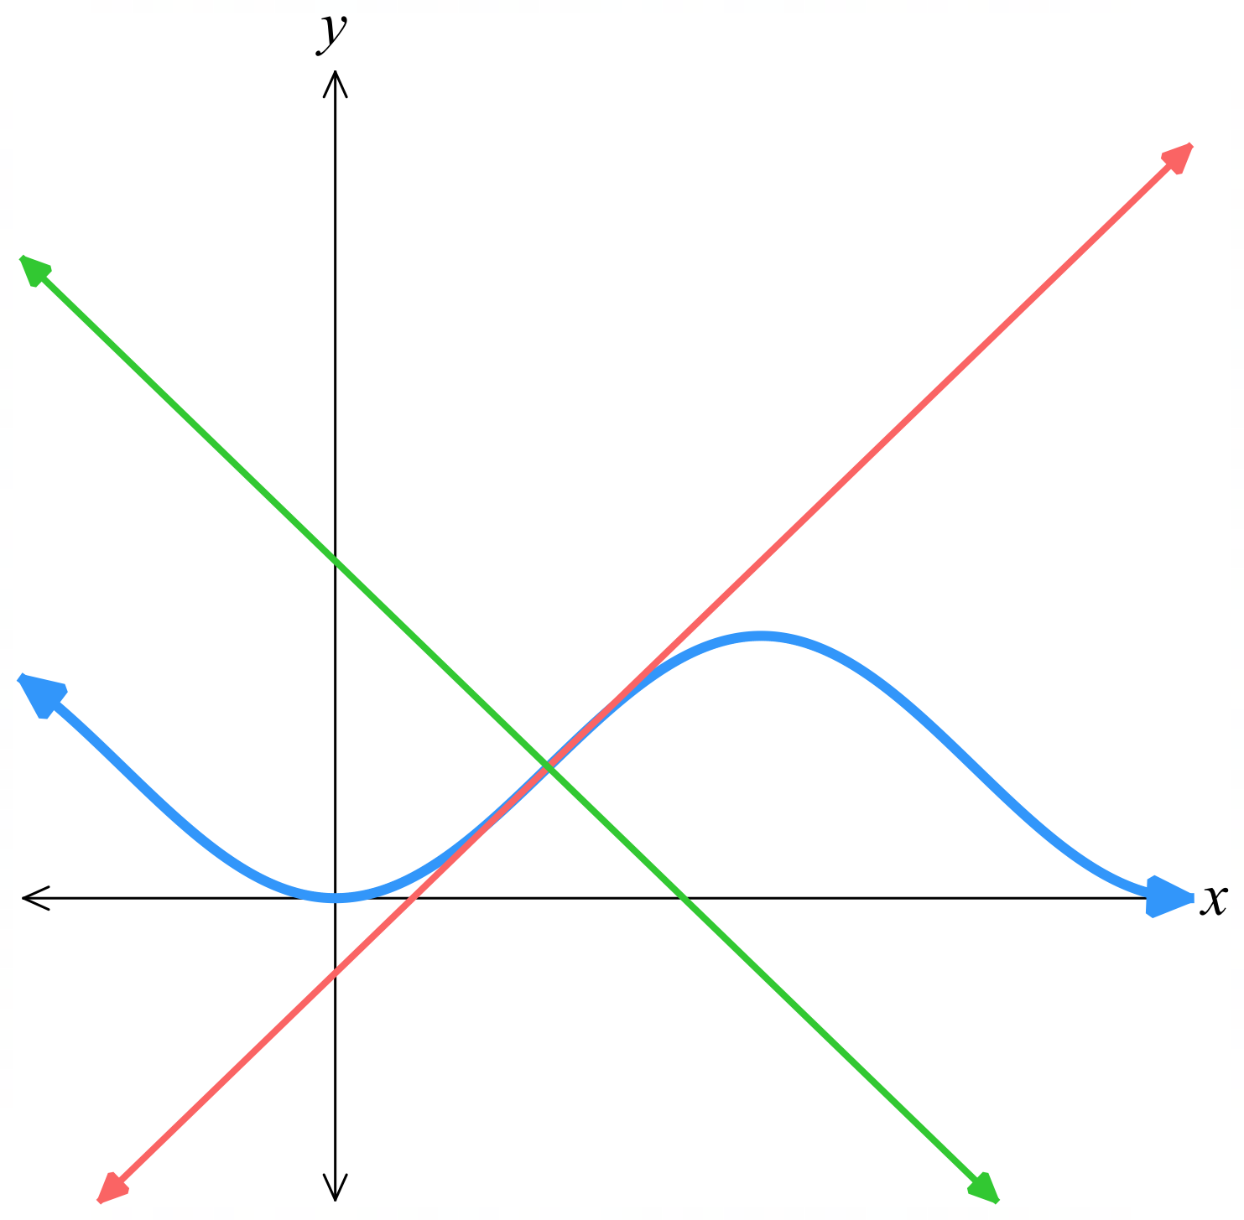
  - Suppose that the tangent meets the $x$-axis at $P$, the normal meets the $y$-axis at $Q$ and $O$ is the origin. Show that $△OPQ$ has area $\frac{\left(π^{2}- 4\right)}{32}$ units².
$$Tangent x - y =\frac{π}{4}-\frac{1}{2}meets x axis \left(y = 0\right):$$
$$x =\frac{π}{4}-\frac{1}{2}, so P = \left(\frac{π}{4}-\frac{1}{2}, 0\right)$$
$$Normal x + y =\frac{π}{4}+\frac{1}{2}meets y axis \left(x = 0\right):$$
$$y =\frac{π}{4}+\frac{1}{2}, so Q = \left(0,\frac{π}{4}+\frac{1}{2}\right)$$

$$Area = \left(\frac{1}{2}\right)\left|OP\right|\left|OQ\right| = \left(\frac{1}{2}\right)\left(\frac{π}{4}-\frac{1}{2}\right)\left(\frac{π}{4}+\frac{1}{2}\right)$$
$$= \left(\frac{1}{2}\right)\left({\left(\frac{π}{4}\right)}^{2}- {\left(\frac{1}{2}\right)}^{2}\right)$$
$$= \left(\frac{1}{2}\right)\left(\frac{π^{2}}{16}-\frac{1}{4}\right)$$
$$= \left(\frac{1}{32}\right)\left(π^{2}- 4\right)$$
$$=\frac{\left(π^{2}- 4\right)}{32}$$

Exam Questions
- HSC Advanced Sample Question Band 4
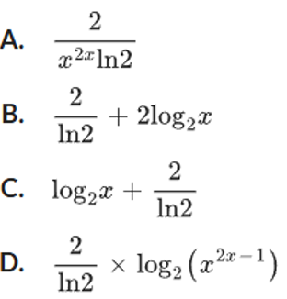
If $f(x) = log₂(x²ˣ),$ which expression is equal to $f'(x)?$

$$f\left(x\right)=2x\log_{2}{x}=\frac{2x\ln{x}}{\ln{2}}$$
$$=\frac{2}{\ln{2}} x\ln{x}$$
$$f^{'}\left(x\right)=\frac{2}{\ln{2}}\left(\ln{x}+1\right)$$
$$=\frac{2 ln x}{\ln{2}}+\frac{2}{\ln{2} }$$
$$=2\log^{2}x+\frac{2}{\ln{2}}$$
B
- HSC Advanced Sample Question Band 4
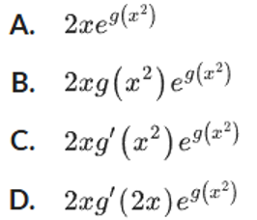
If $f(x) = e^{g\left(x^{2}\right)}$, where g is a differentiable function, find $f'(x)$.

$$f^{'}\left(x\right)=\frac{d\left[g\left(x^{2}\right)\right]}{dx}· e^{g\left(x^{2}\right)}$$
$$= 2x · g^{'}\left(x^{2}\right)· e^{g\left(x^{2}\right)}$$
C
- HSC Advanced Sample Question Band 5
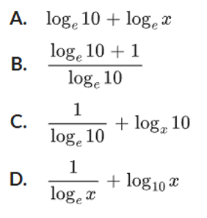
Given $f(x) = log₁₀xˣ$, which expression is equal to $f'(x)$?
$$f\left(x\right)=x\log_{10}{x}$$
$$f^{'}\left(x\right)= x ·\frac{1}{x\ln{10}}+ 1 · log₁₀x$$
$$=\frac{1}{ln10}+ log₁₀x$$
$$=\frac{1}{ln10}+\frac{ln x}{\ln{10}}$$
$$=\frac{ln x + 1}{\ln{10}}$$
B

- HSC Advanced Sample Question Band 4
Differentiate $π²ˣ$

$$y = π²ˣ$$
$$\frac{dy}{dx} = \log_{e}(π) · 2 · π²ˣ$$
$$= 2\log_{e}(π) · π²ˣ$$
- HSC Advanced Sample Question Band 4
Differentiate $5^{x^{2}}· 5x$
$$\frac{dy}{dx}=\ln{5}·2x·5^{x^{2}}·5x+5^{x^{2}}·5$$
$$= 5^{x^{2}}\left(\ln{5} · 10x^{2}+ 5\right)$$
$$= 5^{x^{2}+1}(\ln{5} · 2x² + 1)$$

- HSC Advanced Sample Question Band 4
Differentiate with respect to $x$: $\log_{e} x^{x}$
$$\frac{dy}{dx}= x ·\frac{1}{x}+ \log_{e} x$$
$$= 1 + \log_{e} x$$

- 2024 HSC Advanced Band 4
Let $f(x) = \log_{e}(x³ - 3x + 2).$ Find $f'(3)$
$$f^{'}\left(x\right)=\frac{3x^{2}- 3}{x^{3}- 3x + 2}$$
$$f^{'}\left(3\right)=\frac{6}{5}$$

- 2013 HSC Advanced Band 4
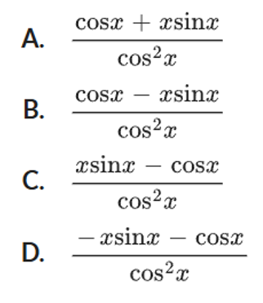
What is the derivative of $\frac{x}{\cos{x}}$?
?

$$\frac{dy}{dx}=\frac{vu^{'}- uv^{'}}{v^{2}}$$
$$=\frac{cos x · 1 - x\left(-sin x\right)}{{\left(cos x\right)}^{2}}$$
$$=\frac{cos x + x sin x}{cos^{2}x}$$
A
- HSC Advanced Sample Question Band 4
Consider the function $f(θ) = sin³(2θ)$.
If $f'(θ) = 6cos(2θ) - 6cosⁿ(2θ)$, find the value of $n$.

$$f(θ) = sin³(2θ) = {\left(sin\left(2θ\right)\right)}^{3}$$
Using chain rule:
$$f'(θ) = 3 × 2cos(2θ) × sin^{2}\left(2θ\right)$$
$$= 6cos\left(2θ\right)\left(1 - cos^{2}\left(2θ\right)\right)$$
$$= 6cos(2θ) - 6cos^{3}\left(2θ\right)$$
$$∴ n = 3$$
- 2007 HSC Advanced Band 4
The point $P(π, 0)$ lies on the curve $y = x sin x$.
Find the equation of the tangent to the curve at $P$.
$$\frac{dy}{dx}=x cos x + sin x$$
$$When x = π$$
$$\frac{dy}{dx}= π × cos π + sin π$$
$$= π(-1) + 0$$
$$= -π$$
$$Equation of line, m = -π, through P(π, 0):$$
$$y - y₁ = m(x - x₁)$$
$$y - 0 = -π(x - π)$$
$$∴ y = -πx + π²$$

- 2025 HSC Advanced Band 5
The graphs of $y = e ln x$ and $y = ax² + c$ are shown.
The line $y = x$ is a tangent to both graphs at their point of intersection.
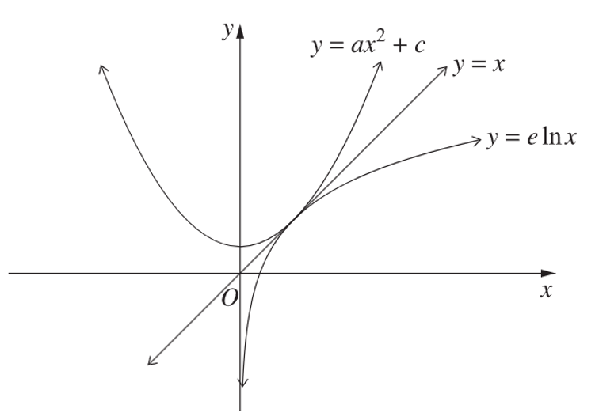
Find the values of $a$ and $c$.
$$y = e ln x ... (1) y = ax² + c ... \left(2\right)$$
$$y^{'}=\frac{e}{x} y^{'}= 2ax$$
At point of tangency, gradient = 1.
Find $x$ such that:
$$\frac{e}{x}= 1 ⇒ x = e$$
At $x = e, y' = 2ax = 1:$
$$2ae = 1 ⇒ a =\frac{1}{2e}$$
Find point of tangency using (1):
$$y = e ln e = e$$
Point of tangency at $(e, e).$
Since (e, e) lies on (2):
$$e = \left(\frac{1}{2e}\right)× e^{2}+ c$$
$$c =\frac{e}{2}$$

$$∴a =\frac{1}{2e}, c =\frac{e}{2}$$

- 2020 HSC Advanced Band 5
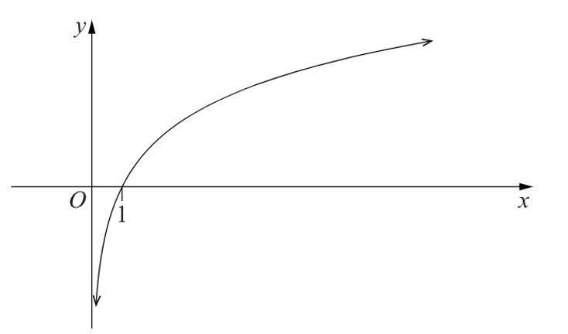
The diagram shows the graph of y = c ln x, c > 0.

  - Show that the equation of the tangent to y = c ln x at x = p, where p > 0, is
$$y =\frac{cx}{p} - c + c ln p$$
  - Find the value of c such that the tangent from part a has a gradient of 1 and passes through the origin.

$$y = c ln x$$
$$\frac{dy}{dx}=\frac{c}{x}$$
At $x = p,$
$$m=\frac{c}{p}$$
Tangent passes through $(p, c ln p)$
∴ Equation of tangent
$$y - c ln p = \left(\frac{c}{p}\right)\left(x - p\right)$$
$$y = \left(\frac{c}{p}\right)x - c + c ln p$$

If m = 1,
$$\frac{c}{p}= 1$$
$$c = p$$
If tangent passes through $(0,0)$
$$0 = -c + c ln c$$
$$0 = c(ln c - 1)$$
$$ln c = 1 (c > 0)$$
$$∴ c = e$$

- 2014 HSC Advanced Band 5
The line $y = mx$ is a tangent to the curve $y = e²ˣ$ at a point $P$.
  - Sketch the line and the curve on one diagram.
  - Find the coordinates of $P$.
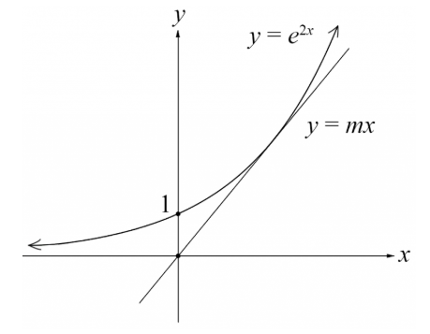
  - Find the value of $m$.
$$y = e²ˣ$$
$$\frac{dy}{dx}= 2e^{2}ˣ$$
Gradient of $y = mx$ is $m$
Gradients equal when
$$2e²ˣ = m$$
$$e^{2}ˣ =\frac{m}{2}$$
$$ln e²ˣ = ln\left(\frac{m}{2}\right)$$
$$2x = ln\left(\frac{m}{2}\right)$$
$$x = \left(\frac{1}{2}\right)ln\left(\frac{m}{2}\right)$$

$$When x = \left(\frac{1}{2}\right)ln\left(\frac{m}{2}\right)$$
$$y = e^{2×\left(\frac{1}{2}\right)ln\left(\frac{m}{2}\right)}$$
$$= e^{ln\left(\frac{m}{2}\right)}$$
$$=\frac{m}{2}$$
$$∴ P\left(\frac{1}{2}ln\left(\frac{m}{2}\right),\frac{m}{2}\right)$$

$y = mx$ passes through $(0,0)$ and $\left(\left(\frac{1}{2}\right)ln\left(\frac{m}{2}\right),\frac{m}{2}\right)$
Using gradient formula:
$$\frac{\frac{m}{2}- 0}{\left(\frac{1}{2}\right)ln\left(\frac{m}{2}\right)- 0}= m$$
$$\frac{\left(\frac{m}{2}\right)}{\frac{1}{2}\ln\left(\frac{m}{2}\right)}=m$$
$$\frac{m}{\ln\left(\frac{m}{2}\right)}=m$$
$$ln\left(\frac{m}{2}\right)= 1$$
$$\frac{m}{2}= e^{1}$$
$$m = 2e$$

